Modify the HTML file and make the layout of table responsive

* In desktop, the table should be grid layout
* In mobile, the table should be list layout
* Cross-browser compatible e.g. chrome, Firefox, IE, etc.
* Make the layout more presentable and user-friendly, especially for mobile

e.g. changing the look of the radio button or it’s container etc.

Desktop layout:

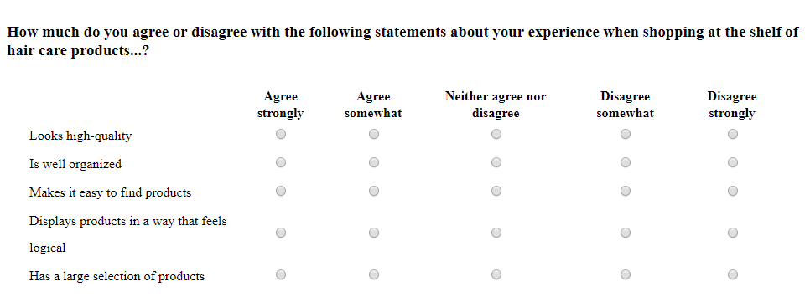

Mobile Layout:

